1. **Project Understanding Section**

The purpose of this project is to provide structural engineering services for a new Engineering Building for Northern Arizona University’s (NAU) Engineering building. This new structure will be submitted to the Structural Engineering Institute (SEI) annual competition. The existing building is at 98% percent capacity and is in need of additional space to accommodate the projected increase in the number of students, and to provide additional laboratory space. The site is located on the south side of NAU’s main campus in Flagstaff, Arizona (Appendix A), surrounded by the NAU’s Forestry, Health Sciences, and Social and Behavioral Sciences buildings. The exact location of the project can be seen in Figure 1.

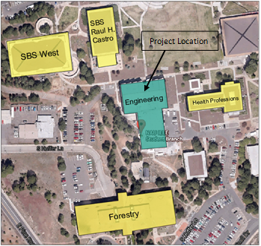

Figure 1: Project Location

In order to complete this project successfully the following technical aspects that will need to be considered.

* Structural Design
* Geotechnical Assessment
* Foundation Design
* Building Requirements

The most important aspects for this project will be compiling multiple design alternatives, selecting the best alternative design and the structural design and analysis of the final design. These will be a key part in this project because the only possible solutions for the overpopulation of the Engineering Building is to construct more space. Therefore the programing or pre-design phase of the project will be key in success of the design. The pre-design phase will incorporate identifying all stake holders and using them to develop the constraints. Once the constraints have been identified we will proceed to create a schematic design. The schematic design will have to address all of the different design options as well as identifying the optimal solution. The primary design will be per the 2009 International Building Code. The load types consist of snow, dead, live, wind and seismic loads. Each type needs to be taken in to consideration during the design process. Prior to the structural design phase it will be necessary to perform a geotechnical analysis of the soil on the project site. This information will be used to determine the foundation constraints. This information will be used to determine the potential cost of retaining structures.

When considering the above tasks a holistic approach is important because it will allow us to complete the best version of this project.. However the amount of analysis needed to design a building will far exceed the scope of this class because it normally takes a large design team months to complete a project of this size. For this reason, the team will focus their scope on meeting the following criteria of the ASCE SEI competition [3]:

* **Format** – choice of an appropriate format, suitable for presentation to a client (10%)
* **Material** - technical or theoretical content correctness (30%)
* **Demonstrated Knowledge and Understanding of Subject** - depth of knowledge (20%)
* **Originality and Complexity** - design and discussion innovative (20%)
* **Presentation** - neatness, style, organization, clarity and readability (20%)

Although 20% of the score is based on originality, the technical aspects (material and understanding of the subject) of the project are 50% of the overall grade. Thus, while originality is important, the technical context is more important. Challenges are inevitable while designing this structure but they will arise less often if the schedule is followed properly.

**2.0 Scope of Services**

This section of the proposal will go into the details of the different tasks that are required by the Structural Engineering Institute project. These tasks will include but are not limited to structural design, structural analysis, geotechnical design, and geotechnical analysis. The project has many different facets that will have to be completed in a timely manner.

**2.1 Site Evaluation**

The site evaluation task will consist of examining existing features on and around the project site.

**2.1.1 Existing Structure Evaluation**

The existing structure must be assessed in order to decide whether or not the additional building can be structurally connected to it. For the existing structure to be analyzed it must first be modeled in RISA 3D. Modeling the current structure will have to include the building that was constructed in 1971, as well as the building constructed in 2005. Having all current structures modeled will help determine the quality of the individual structures. It will also aid in the understanding of how they interact. The plans for the 2005 addition and the 1971 building have been collected and will be used to model each structure.

**2.1.2 Existing Soil Evaluation**

Evaluating the soil properties will include the review of the soil under the entire project site as well as in the surrounding areas.

**2.1.2.1 Information Gathering**

Information gathering will entail the collection of soil reports from the previous construction on the site. It will also include going through the soil reports and sifting out the unnecessary data, so only the required information is being used. Once the data has been accumulated properly the analysis can be conducted.

**2.1.2.2 Analysis: Soil**

Soil analysis will consist of inputting the data from the previous task into software and determining the soil quality. The quality of the soil will be based on the type of soil in the area, the depth to bedrock, the depth to the water table and the saturation level of the soil. The USGS method of soil analysis will be used to evaluate the soil. It will take into account the previously mentioned attributes so that an analytical assessment can be made.

**2.2 Standards/Codes**

For this task, time will be allotted to examine the structural codes that need to be followed throughout the design process. These codes will serve as a guidelines for the project.

**2.2.1 Structural Codes**

The International Building Code (IBC) 2009 [4], American Society of Civil Engineers (ASCE) 7-10 [5], and the American Concrete Institute (ACI) 318-11 [6] codes will be frequently referenced when designing the structure of the new addition. The ASCE 7 will help finalize the design to account for all possible loading conditions. The ACI will assist in finalizing any concrete beam or column design to maximize efficiency and cost. The IBC will help tie in all the extra aspects of the structural design to ensure it meets international safety requirements.

**2.3 Design: Structure**

This will be the most important and time consuming task and will be reliant on all of the other tasks within the scope of the project.

**2.3.1 General Structural Design**

The design of the structure will include a schematic design of the new addition. The schematic design will show the type of structure, overall size, details of critical beams and columns, and the column locations. The schematic design will adhere to the client specified space constraints.

**2.3.2** **Detailed Structural Design**

Before submitting a 50%, 90%, and 100% final design, certain criteria must met. For the 50% design a working structural model of the existing building as well as a basic layout of the proposed design will be included. For the 90% final design a few detail views will be provided showing the types of beam connections in the proposed design. Lastly for the 100% final design elevation views, the rest of the detail views, and plans for the foundation and each floor of the building will be generated.  The design will be completed using the software RISA and Revit [1] [2].

**2.3.3 Internal Features**

Space will be allocated appropriately for internal features such as classrooms, labs, electrical units, offices, and restrooms. These features are based on Northern Arizona University’s Engineering Department’s growth rate. The different internal needs of the building, such as heavy lab equipment, will need to be incorporated into the foundation, as well as the over structure.  This is information was found using Student Growth Predictions and the New Engineering Building [7] and Engineering Data Growth Predictions [8].

**2.4 Design: Geotechnical**

The following geotechnical aspects must be considered when performing the structural design for the new addition.

**2.4.1 Foundation Analysis**

The existing foundation will need to be re-analyzed to determine the magnitude, if any, of its additional load capacity. If it cannot support the weight of the proposed addition then other options will need to be considered. The existing building rests on multiple spread footings and drilled piers that can be modeled in Bentley Geostructural software or even in RISA 3D. The foundation for the building in 2005 was constructed using drilled piers and the foundation for the original 1971 building was constructed using spread footings.

**2.4.2 Excavation**

The cost of soil excavation will be another aspect to consider when deciding on the final design. Depending on the where the addition will be, there could be significant amounts of soil being removed. For example: if the addition was to extend to the South or West then a large amount of soil and rock would need to be removed to make room for the first and second floors.

**2.4.3 Retaining Wall Estimates**

Retaining walls will be another geotechnical aspect to consider when picking a final design. Generally, if a large amount of excavation is required, then larger retaining walls will be needed for either temporary or permanent applications.

**2.5 Deliverables**

The timely submittal of project documentsis essential in deciding the overall success of the project. The main deliverables are outlined below.      

**2.5.1 Project Schedule**

The project schedule will be an integral part of the overall project success. The schedule will detail all start and end dates as well as milestones. It will also cover the dependencies of each task and the critical path to the completion of the project.

**2.5.2 50% Design Documents**

The 50% design report will include preliminary aspects of the final design. The report will be submitted to the client and reviewed for any final changes or suggestions that should be included in the design before the final design report is presented.

**2.5.3 90% Design Documents**

The 90% design document will includea few detail views, showing the types of beam connections in the proposed design. It will also include all drawings from the 50% design document task with revisions completed.

**2.5.4 100% Design Documents**

The final report will include all design drawings and specifications for the new additions structure. It will also detail the new foundation and any other minor structures that are needed for the completion of the project.

**2.5.5 Website**

A website will be created to provide a detailed project description that includes design specifics and team related information. This website will be viewable on the NAU College of Engineering Forestry and Natural Sciences (CEFNS) capstone webpage. The first part of the webpage will be completed along with the proposal.

**2.5.6 Presentations**

The final presentation must supply a technical level sufficient for an audience of “general” engineers. It must convey the scope of the project and how it relates to the needs of the project. The final design or solution along with relevant details should be thoroughly explained within the final presentation.

**2.6 Exclusions**

The exclusions listed in the following section will need to be taken into account but are not a part of our scope of services.

**2.6.1 Permitting**

The city of Flagstaff requires numerous permits to construct new buildings in their area. These permits address the review of building, plumbing, mechanical, energy, and accessibility requirements. The Environment Protection Agency also requires permits for storm water discharges from the construction site. All of these permits will have to be taken into account before the construction phase begins.

**2.6.2 Underground Utilities**

The current structure has numerous underground utilities incorporated into it. During the foundation design for the new addition these utilities will be considered but the exact locations will not be defined. Before construction the utilities must be taken into account.

**2.6.3 HVAC**

Heating, Ventilating, and Air Conditioning (HVAC) systems will need to be incorporated into the design so that its weight can be included into the structure. Although the system will be taken into account the specifics of the system will not be shown in the final design report.

**2.6.4 ADA**

The Americans with Disabilities Act (ADA) requires accessibility standards for design. The current regulations are detailed in the 2010 ADA Standard. These standards may influence our design but will not be specifically detailed or incorporated into the building.

**3.0 Schedule**

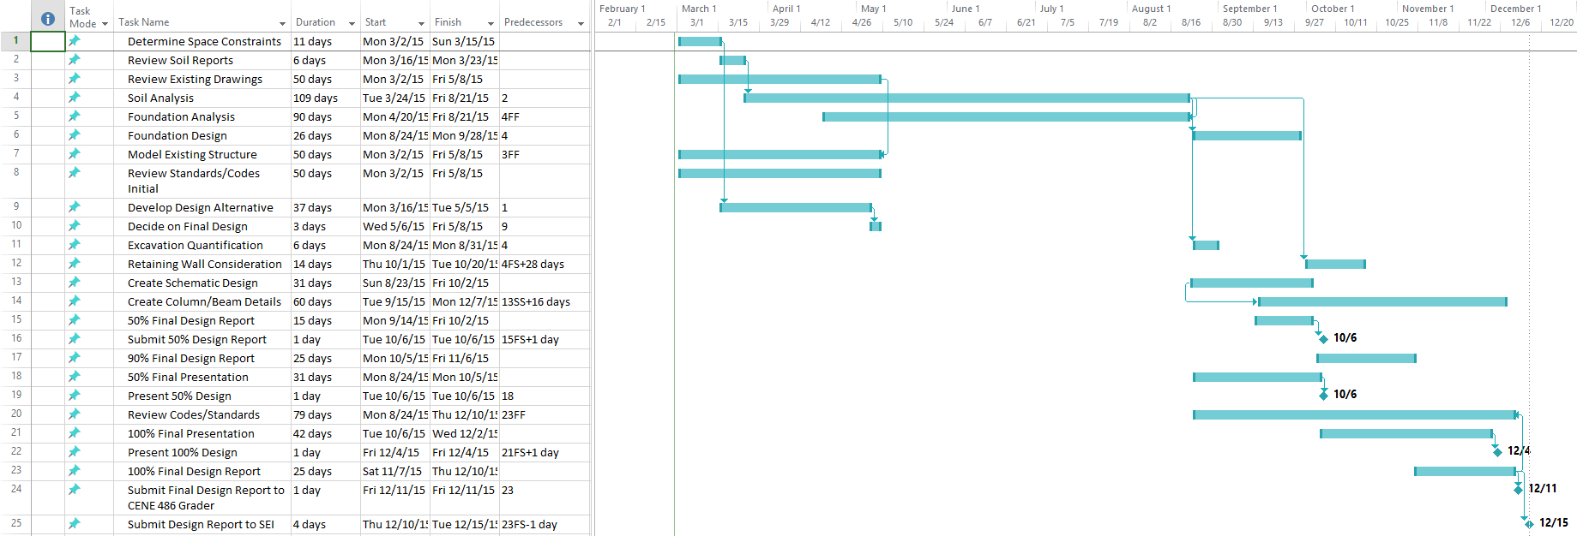

Figure 2: GANTT Schedule

Figure 3: GANTT Schedule

The gannt chart above shows the timeline from the beginning to the completion of the project. The arrows in the gannt chart show which tasks are correlated, as well as how they are correlated. The arrows also help to show the critical path the project must follow in order to complete it in the shortest amount of time.

**4.0 Staffing Cost**









Resources

[1] *RISA 3D. Vers. 11. Foothill Ranch: RISA Technologies, 2013. Computer software.*

[2] *Revit*. Vers. 2015. Greenwood Village: IMAGINiT Technologies, 2015. Computer software.

[3] ASCE, http://www.structurescongress.org/program/student-competition/, date accessed January 30, 2015

[4] (COR), International Code Council. *International Building Code, 2012*. 1st ed. Vol. 1. Country Club Hills, IL: International Code Council, 2011. Print.

[5] Simiu, Emil. *Design of Buildings for Wind a Practical Guide for ASCE 7-10 Standard Users and Designers of Special Structures*. Hoboken: Wiley, 2011. Print.

[6] Committee, ACI 318. *Building Code Requirements for Structural Concrete (ACI 318-11) and Commentary*. 1st ed. Vol. 1. Farmington Hills, MI: American Concrete Institute, 2011. Print.

[7] Penado, Ernesto, Bridget Bero, and Dave Scott. *Student Growth Predictions and the New Engineering Building*. Issue brief. N.p.: n.p., n.d. Print.

[8] Staff, Engineering. Engineering Data Growth Predictions. 2014. Raw data. Northern Arizona University, Flagstaff.

Appendix A

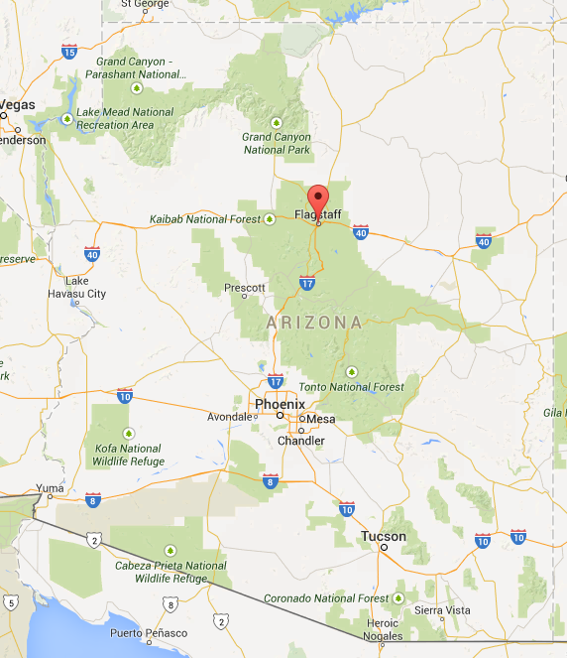

Figure A-1: Flagstaff, AZ